**Challenge**

As the host of the party, you would like to see both men and women mingling within the groups. Adjust the tolerance slider on the side of the view to get all groups to be mixed as an end result.

**To make sure all groups of 10 have both sexes, at what level should we set the tolerance?**

**Answer**: >=14

**Can you see any other factors or variables that might affect the male to female ration within each group?**

**Answer:** When the tolerance is less than 15 then they start to mix together but the model never stops. Also, the Number Happy it never goes to 150. The number of groups are 10 but they only gathered to the half of them. The half groups are empty.

Make predictions and test your ideas within the model.

As you are testing your hypotheses, you will notice that patterns are emerging from the data. For example, if you keep the number of people at the party constant but gradually increase the tolerance level, more mixed group appear.

**Tutorial #1 – Wolf Sheep Predation**

Press the “setup” button. What do you see appear in the view?

**Answer**: Grass, Sheep, Wolfs

Press the “go” button to start the simulation. As the model is running, what is happening to the wolf and sheep populations?

**Answer**: At first sheep population increases over time but then started to decrease because wolfs eat them and then wolfs population started to increase until they eat all the sheep. Then eventually wolfs have nothing to predate, they starve, and they die. So over time both populations comes to zero.

Do you ever get different results if you run the model several times with the same settings?

**Answer:** Yes, sometimes wolfs eat all the sheep but sometimes 1-2 sheep can survive and reproduce and inherit the earth while all the wolfs are dead.

What would happen to the sheep population if there were more sheep and less wolves initially?

**Answer:** If we run the model for just 100 ticks the sheep are going to reproduce a lot while the wolfs are slightly starting to reproduce again. After that moment sheep population will start decreasing rapidly

What happened to the sheep population?

**Answer:** It always goes to 0.

What other sliders or switches can be adjusted to help out the sheep population?

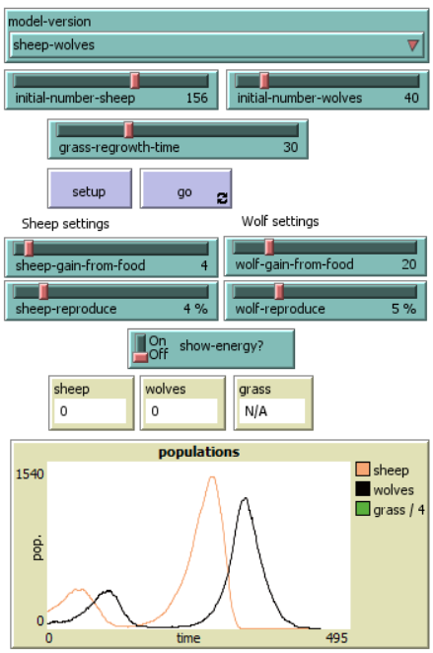

What happened to the wolves in this run? (adjusted values given)

**Answer:** Sheep reproduced really fast but the wolfs wherever they go they found sheep, that means = food/energy everywhere. The sheep population went to 0 in a few ticks but the wolfs population last a little bit longer because they consumed a good amount of energy.

Press “setup” and then “go” to start the model running. As the model runs, move the speed slider to the left. What happens?

**Answer:** It slows the speed down.

Now move the speed slider to the right, now try checking and unchecking the “view updates” checkbox. What happens?

**Answer:** It moves really fast but when I check and uncheck the View Updates checkbox, it shows or removes the visual updates (each tick) of the model. Also unchecking the box, it saves some processing power and it can be useful when if you are impatient. The model still runs in the background and plots and monitors are still update.

**Checkpoint Questions:**

1. What are the four types of agents in NetLogo? Which types are mobile, and which are not? For each type of agent, find a model in the library which uses agents of that type.

**Answer:** The four types of agents are: turtles, patches, links and the observer.

* Turtles are agents that move around the world.
* The world is a two dimensional and is divided up into a grid of patches. Each patch is a square piece of “ground” over which turtles can move. Patches CAN’T move.
* Links are agents that connect two turtles.
* The observer doesn’t have a location. When in follow or ride mode the observer moves with the subject agent around the world. When is in watch mode it tracks the movements of one turtle without moving.

Observer: Doppler Model

Turtles: Wolf Sheep Predation Model (Wolves and Sheep)

Patches: Wolf Sheep Predation Model (Grass)

Links: Communication T-T Example Model (link agents to represent a network)

1. What is the shape of the “world” in the model you are currently looking at? Is it a square, a cylinder, or a torus? Where is its origin? (Hint: look at the model setting using the button on the Interface tab.) Make a note which model your answer refers to.

**Answer:** It’s a square looking but it wraps vertically and horizontally, and it has a Center location of origin. Wolf Sheep Predation Model (Torus)

**Tutorial #2 – Commands**

* Using Traffic Basic Model
* Press “setup” button
* Locate the Command Center
* Type the text shown to the Command Center
* Ask patches [set pcolor yellow]
* What happened to the View?

**Answer:** The background colour of the model changed to yellow and the street disappeared.

Why didn’t the cars turn yellow too?

**Answer:** Because we changed the colour of the patches. In this model the cars are represented by a different kind of agent, turtles. Therefore, the cars did not receive these instructions and thus did not change.

Type: ask turtles [set color brown]. Was the result what you expected?

**Answer:** Yes, the cars (turtles) changed colour.

The Command Center doesn’t permanently change the model, so when the “setup” button is pressed everything is reverted.

What is the difference between color and pcolor? We call color and pcolor “variables”. The color variable is a turtle variable, while the pcolor variable is a patch variable.

* Press “setup” to get the red car to reappear.
* Right-click on the red car.
* Inspect turtle

What is this turtle’s who number?

**Answer:** 6

What colour is this turtle?

**Answer:** 15

If you try to have the observer ask patch 0 [set pcolor blue], you’ll get an error message. To ask an individual turtle to do something, we use its who number. But patches don’t have who numbers, therefore we need to refer to them some other way.

**Mushroom Hunters**

In the Mushroom Hunt model, we create four clusters of red patches. For each of these clusters, we ask 20 patches to turn red. Are there always 80 red patches? You can check this very quickly using the Command Center, entering the statement show count patches with [pcolor = red]. Do this several times after hitting Setup each time. Why do you get the answers you do?

**Answer:** Sometimes it shows 79/75/77/76 and probably is because of the radius of the patches the radius is 5 so when a cluster of mushrooms are close to each other it can overlap. If we change the world to double its size it will most likely shows 80 because the mushroom clusters are far away from each other.

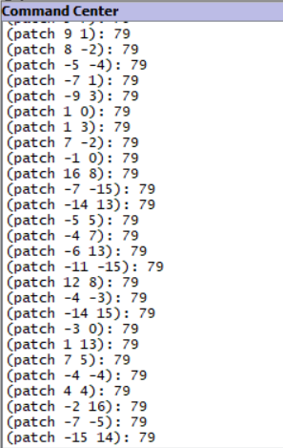

How should you program the hunter’s search strategy? The book suggests that to get the hunters to continue searching in the same area, they should turn by a large angle and then move forward. Otherwise they should turn by a small angle and then more forward. The code below achieves this, though you may be able to improve on this.

**Answer:** Maybe we can spawn the hunters on the corners e.g. Lower right corner instead of middle and when the hunter had not recently found a mushroom, it turns by a random angle between -45 and +45 degrees instead of between -10 and + 10. Also, it can be helpful if the hunter’s initial heading is always 45 degrees.